Rebuilding Iraq New Updates

1. Update the tender details with ql editor embedded so it shows like the picture below. The current Material UI text box just shows an inline text once it is loaded. It lacks formatting. The photo on the left is how it looked on the old platform and the right is the one we built.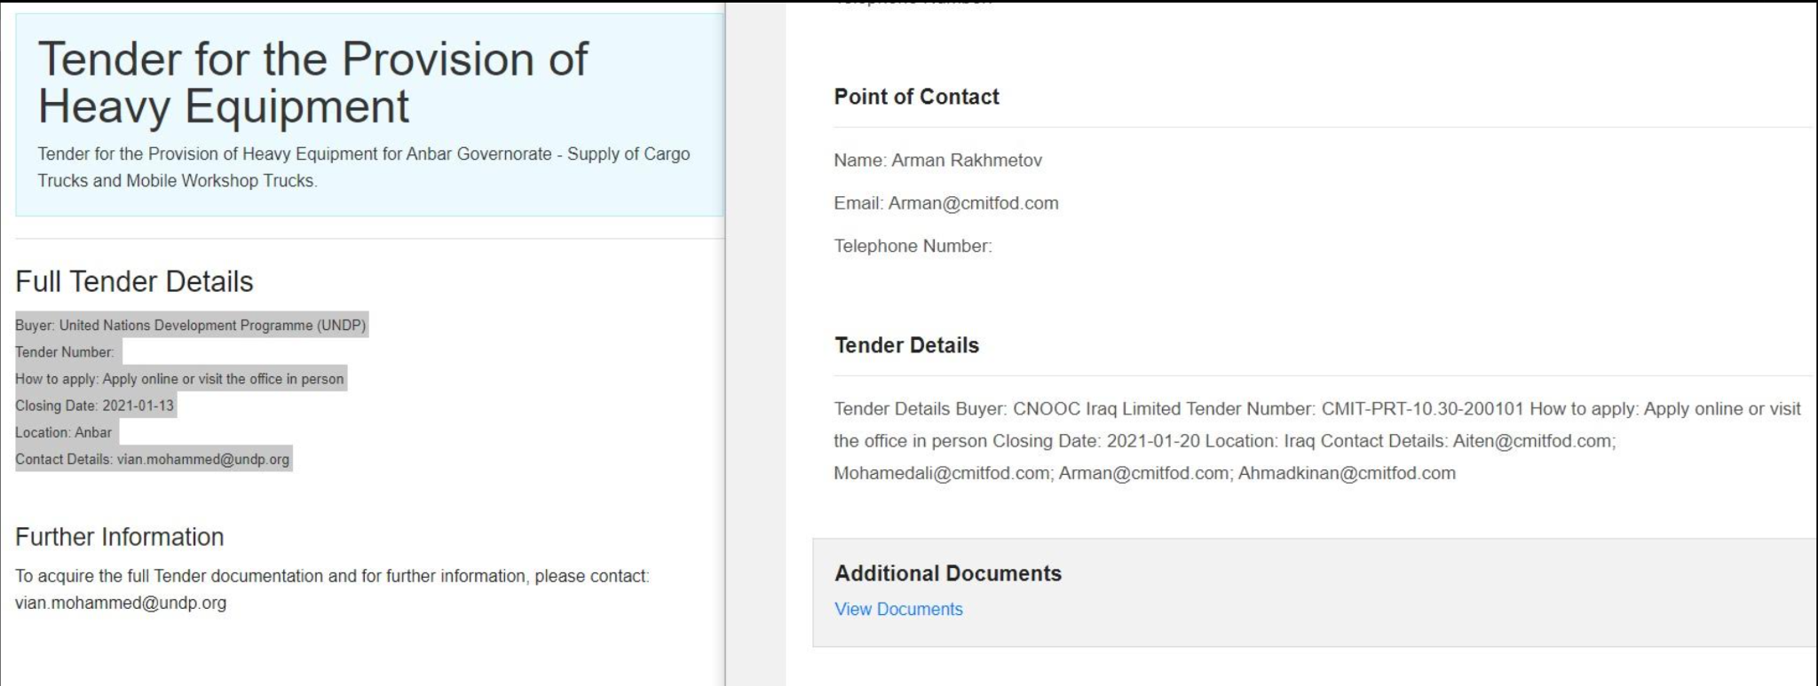
2. When a user that does not have an account clicks on a tender, it should at least show the title and category. Click on this one for example and you will see that it does not show anything - <http://52.87.229.68:3456/tenders/Tender-for-General-Coordinator>. The photo below is how it used to look on the old platform.

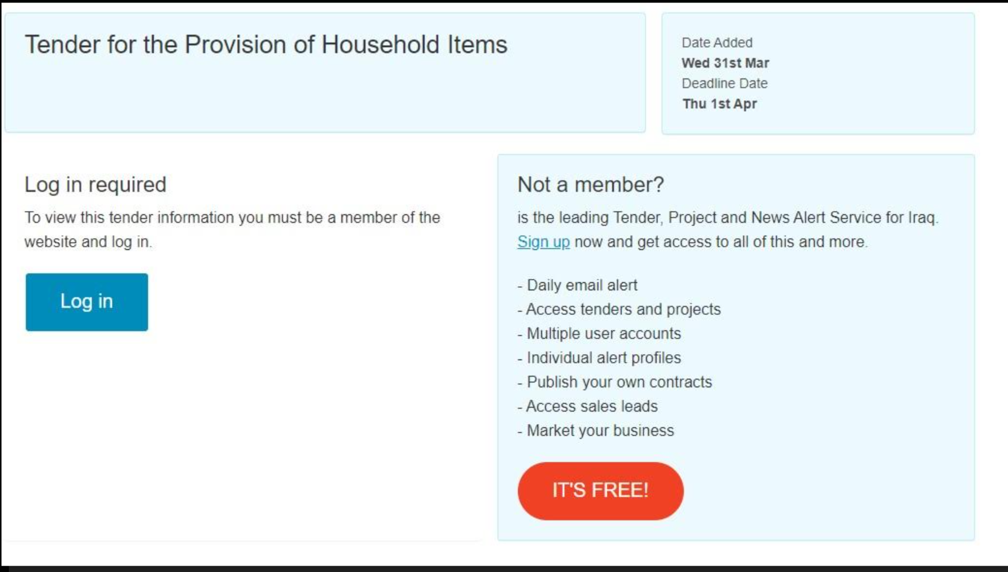

1. The homepage search bar does not show any results, maybe get that working.